**Cloud Messaging Framework**

Block diagram:

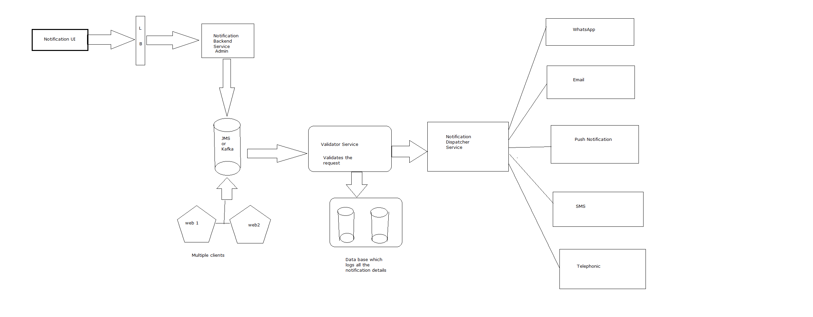

**Tech Stack:**

Admin backend service: Spring Boot (Batch service)

Messaging service: RabbitMQ/Kafka

DB: PostgreSQL

Validator Service-> Spring boot

Notification Dispatcher Service: Spring Boot for individual medium plus rest APIs

**DB Design**

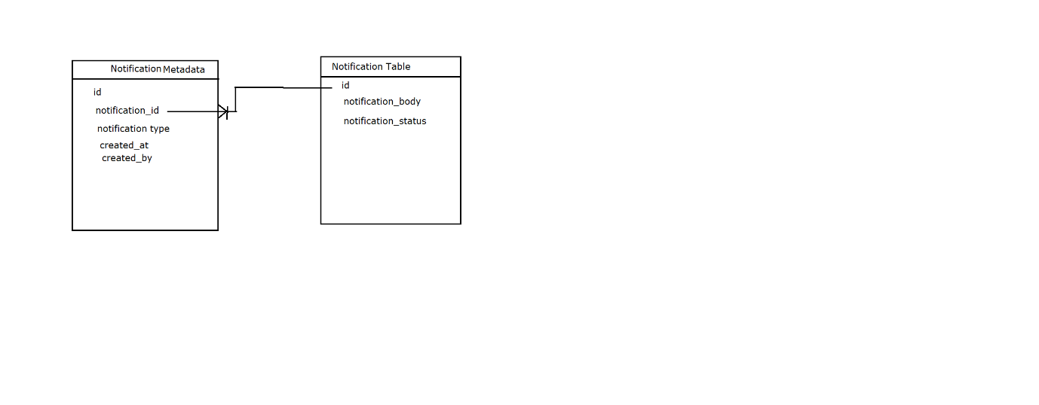

DB: PosgreSQL

Backend Service:

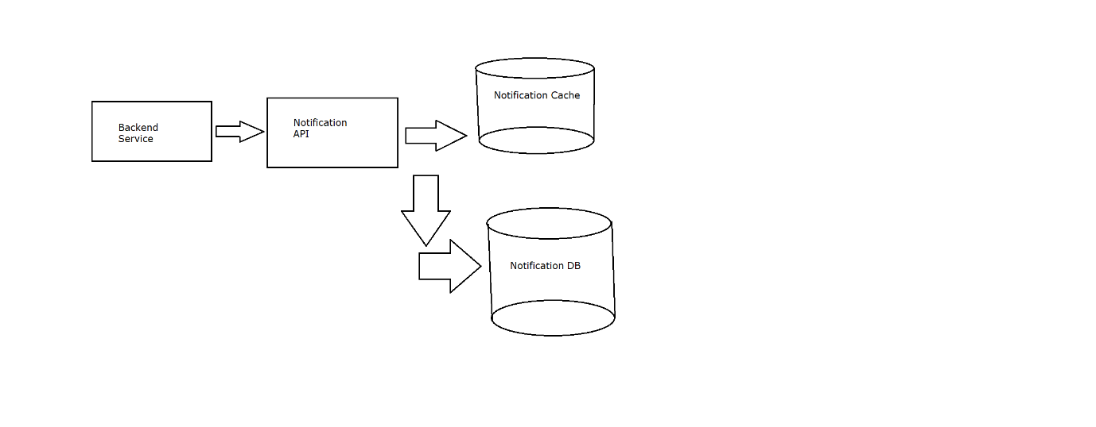

The API schema could roughly look like the following:

createNotification(APIKey, ProductID, userID)

deleteNotification(APIKey, NotificationID)

getNotifications(APIKey, userID)